**MirrAR QA INTERN TASK – BUG Report**

**TEST URL:** https://sakshi.mirrar.com/

**TESTER NAME:** RINI SARAVANAN

**TESTED DATE:** 13/01/2024

**TESTED BROWSER:** GOOGLE CHROME

**BUG 1:**

While opening the test URL, we are getting like the below page:

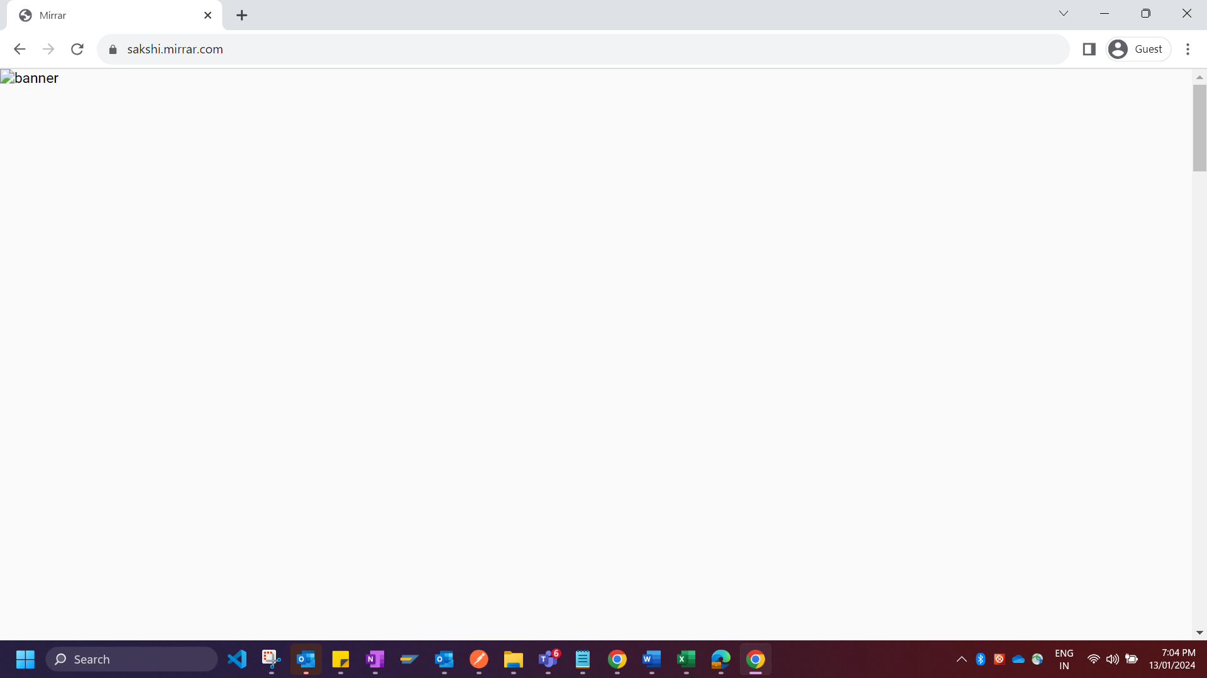

We could be able to see the below page only if we scroll down a little bit from the page which has been opened directly from the test URL,

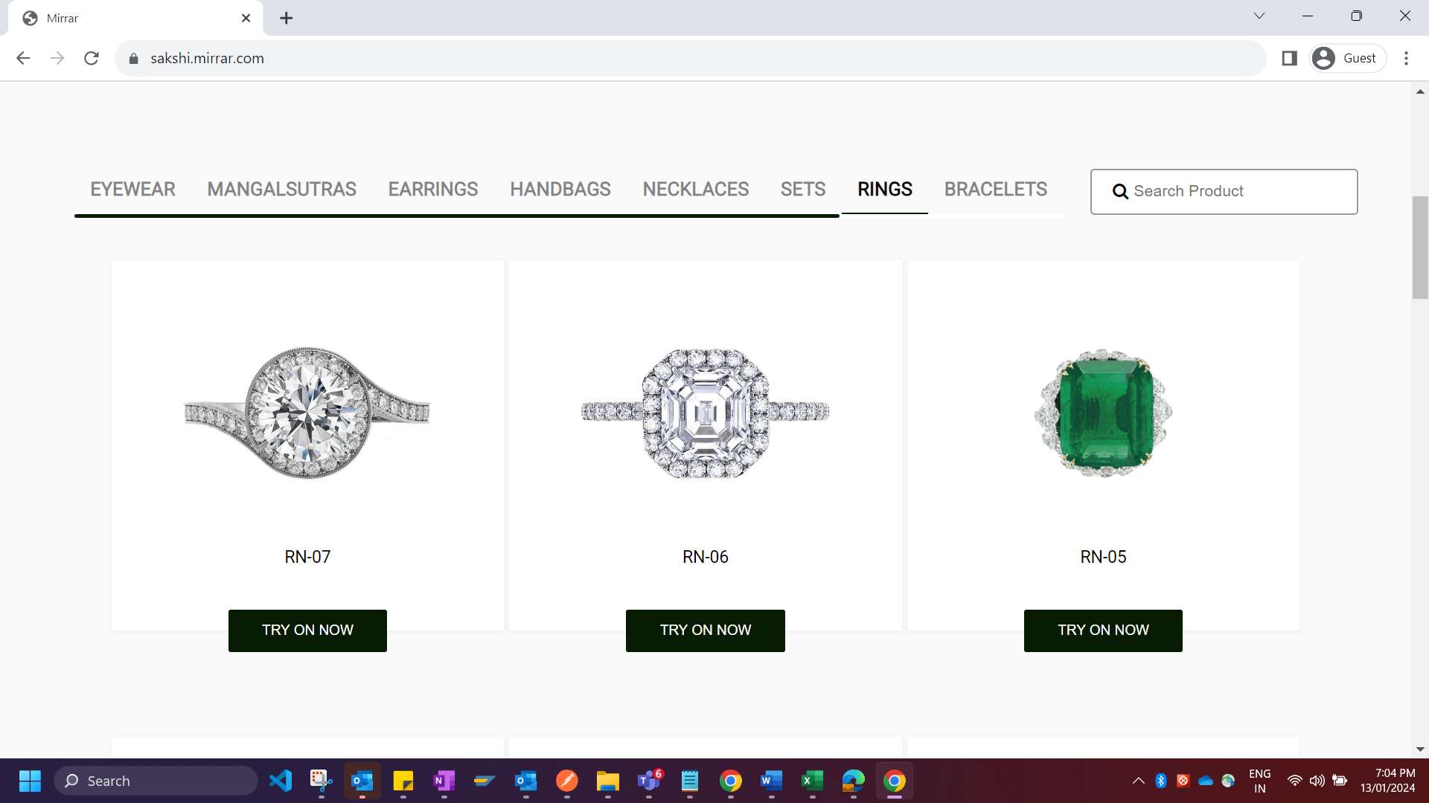

**BUG 2:**

PENDANTSETS category is not visible at all in any of the different pages.

Home Page

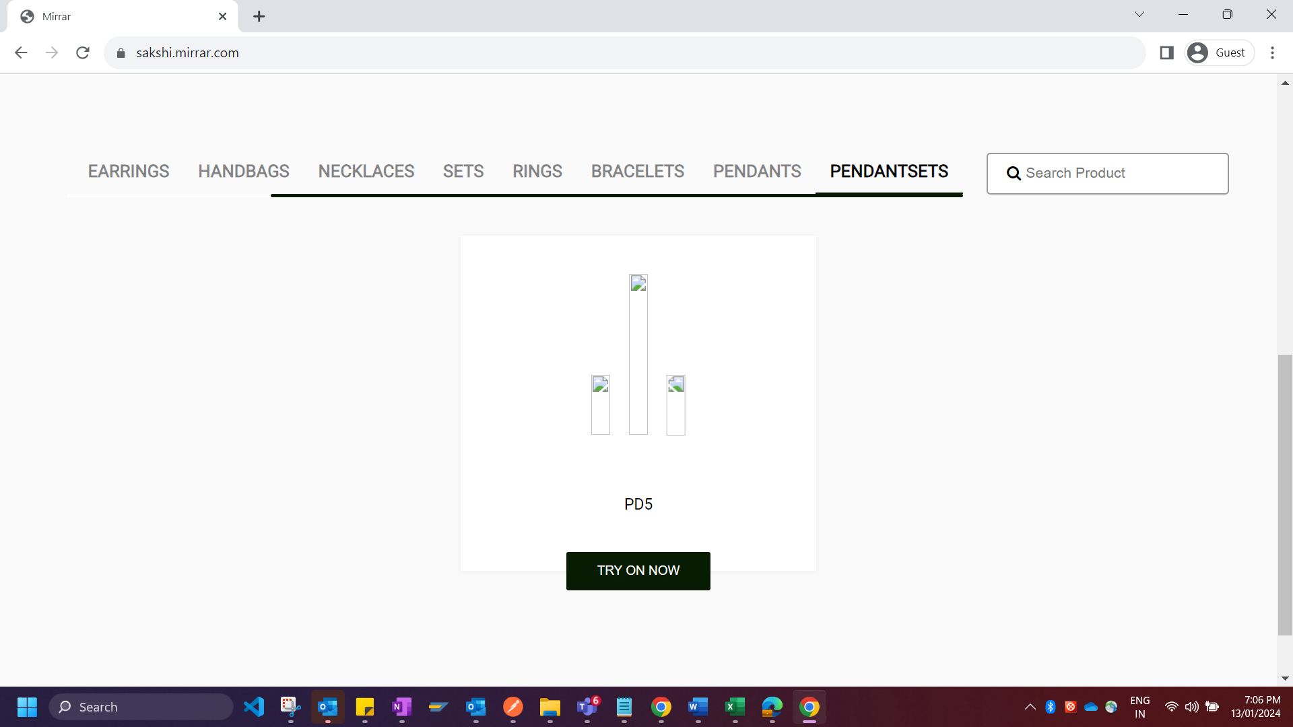

In Model Feature

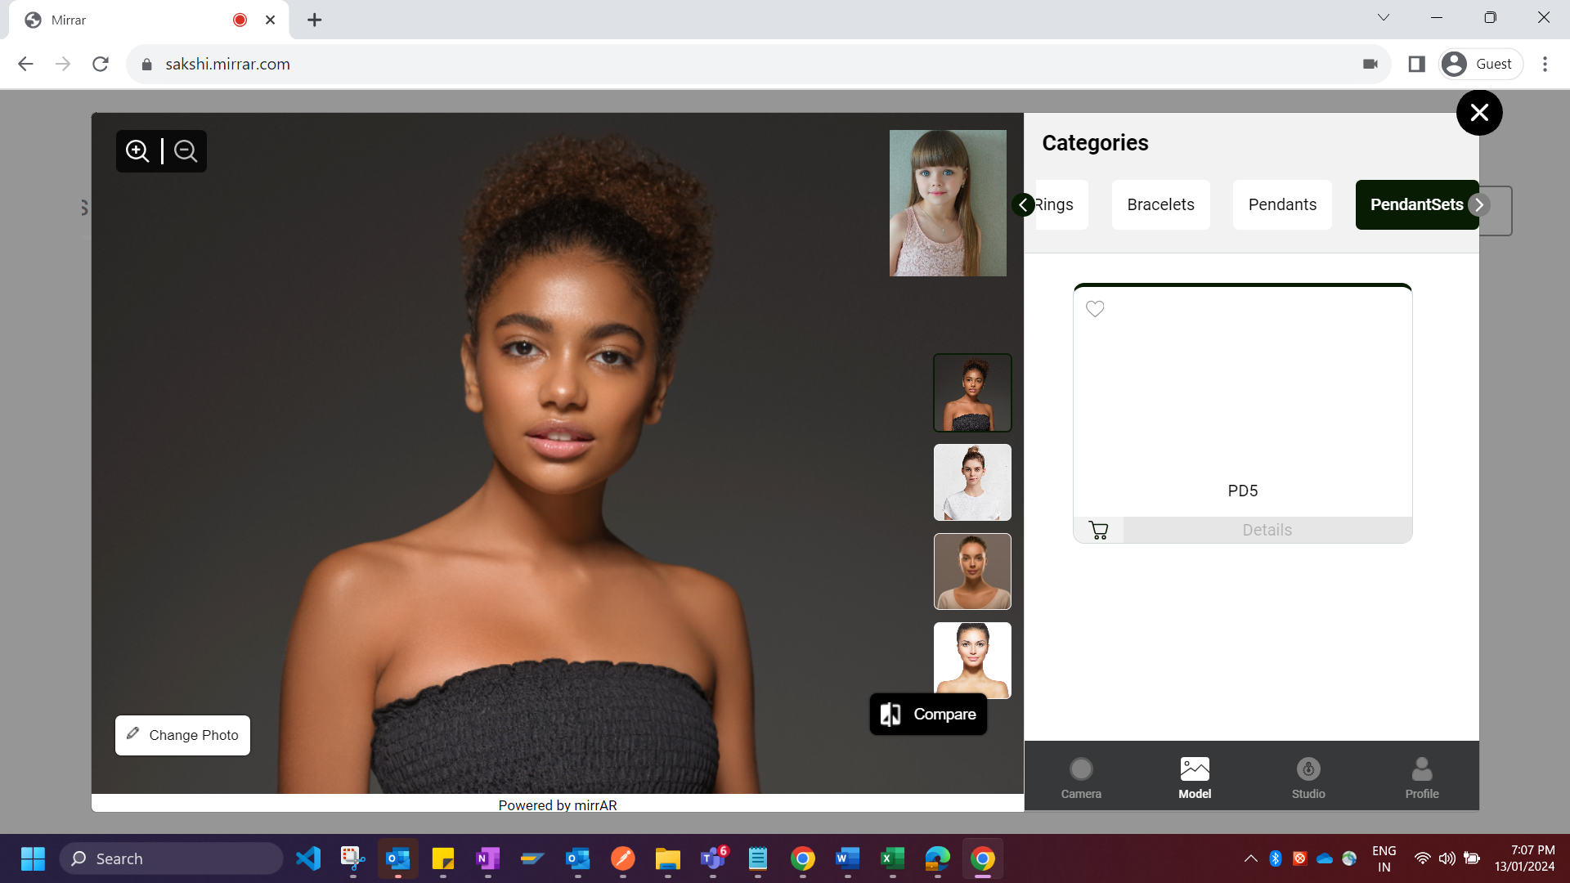

In Studio Feature

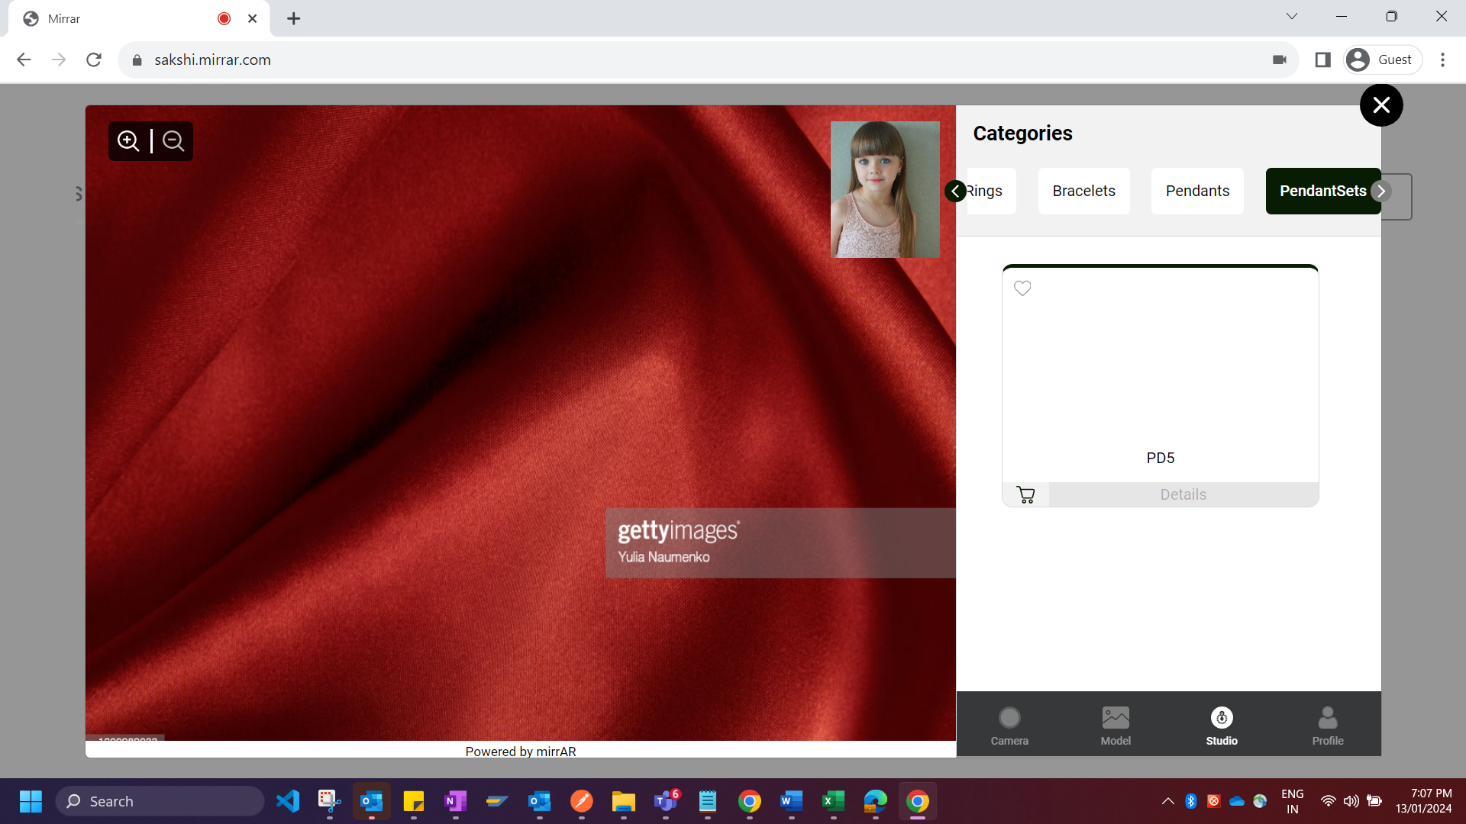

In Camera Feature

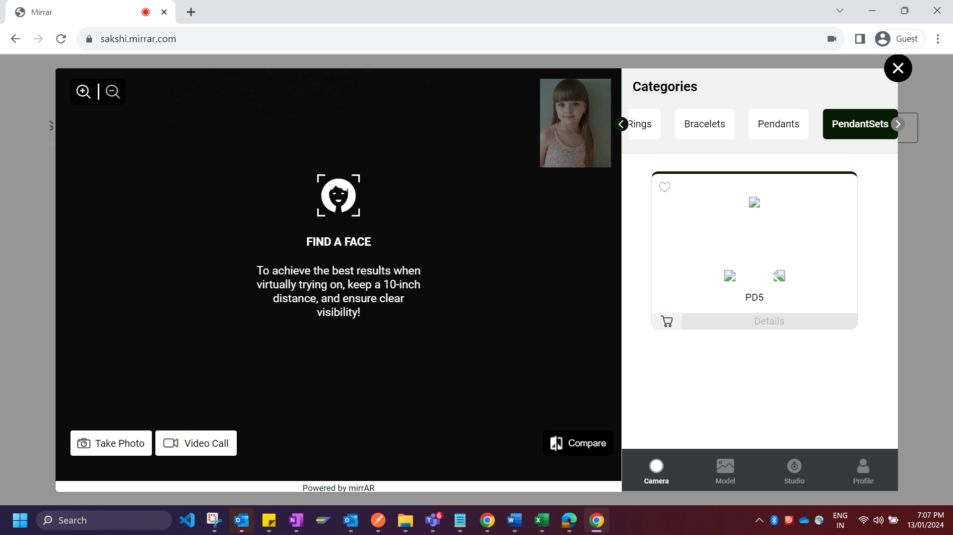

**BUG 3:**

Some of the irrelevant product items exists in the specific categories.

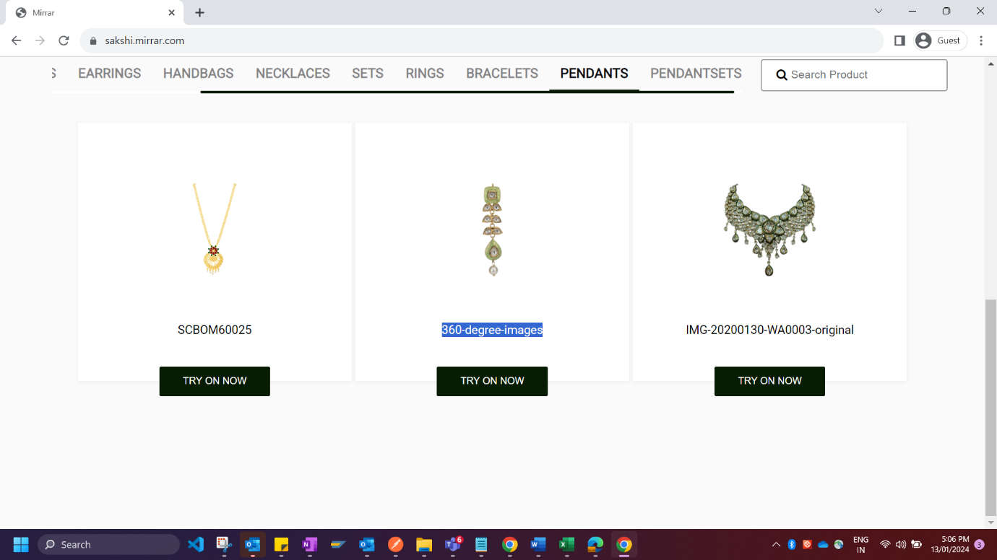

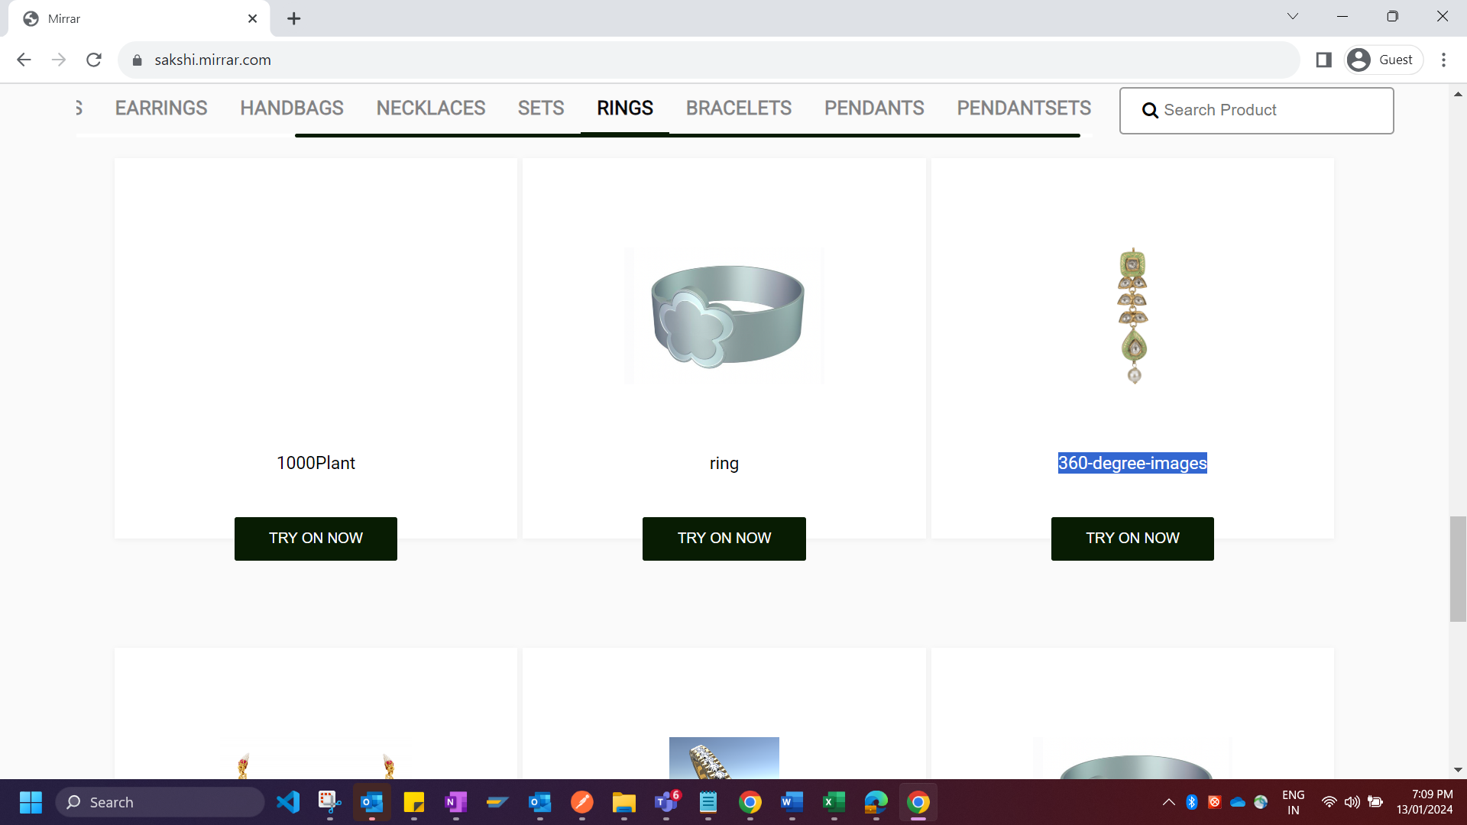

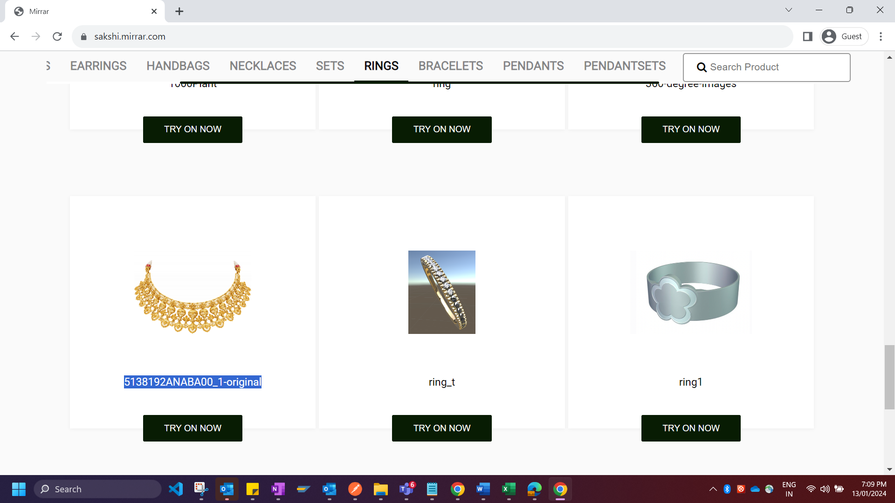

**BUG 4:**

Few product items are not visible.

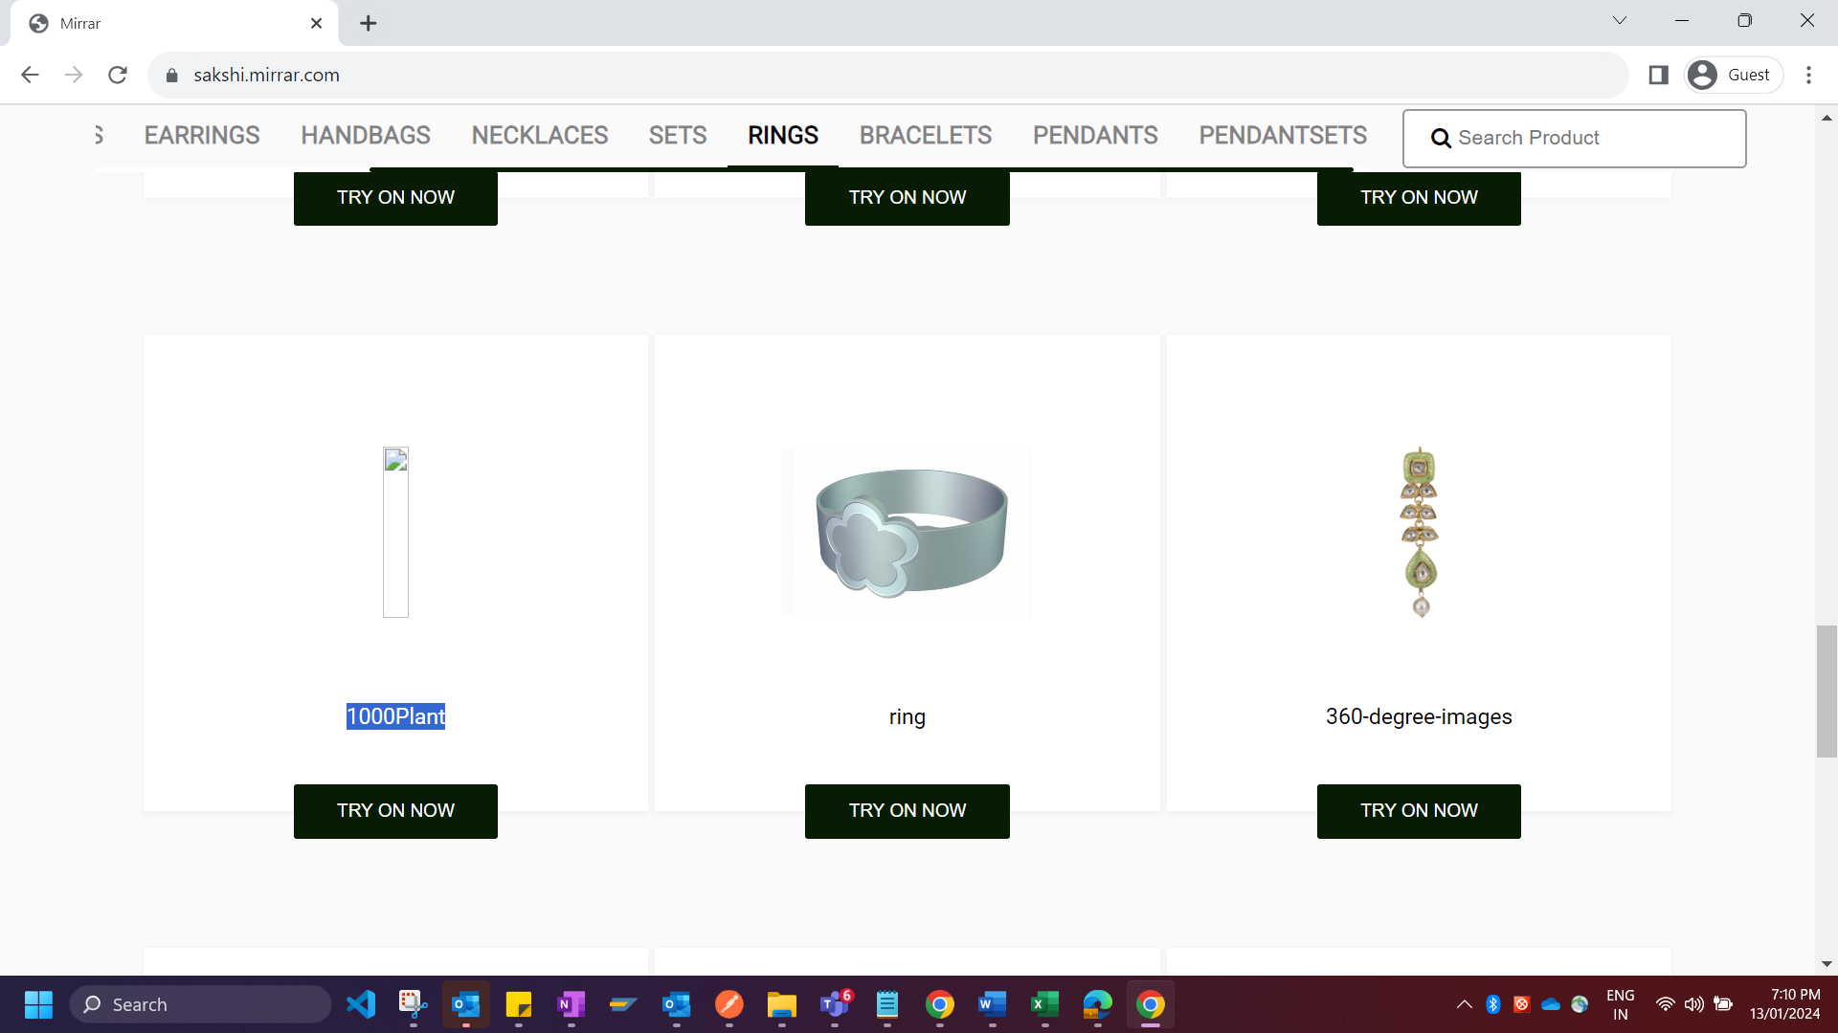

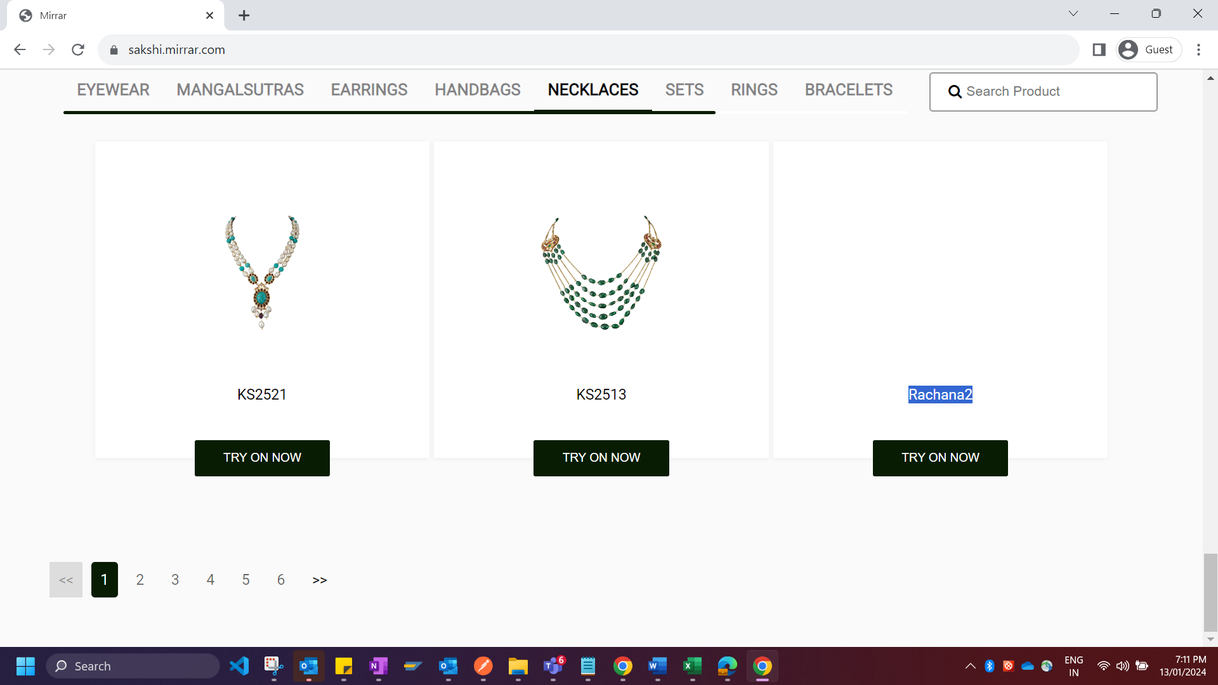

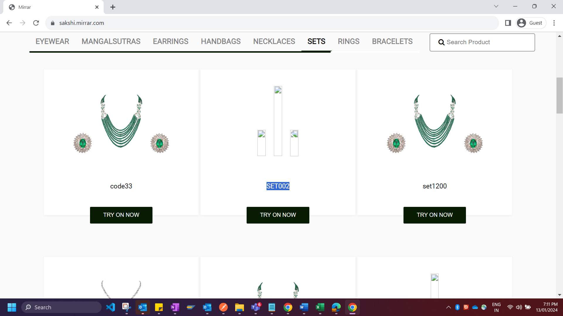

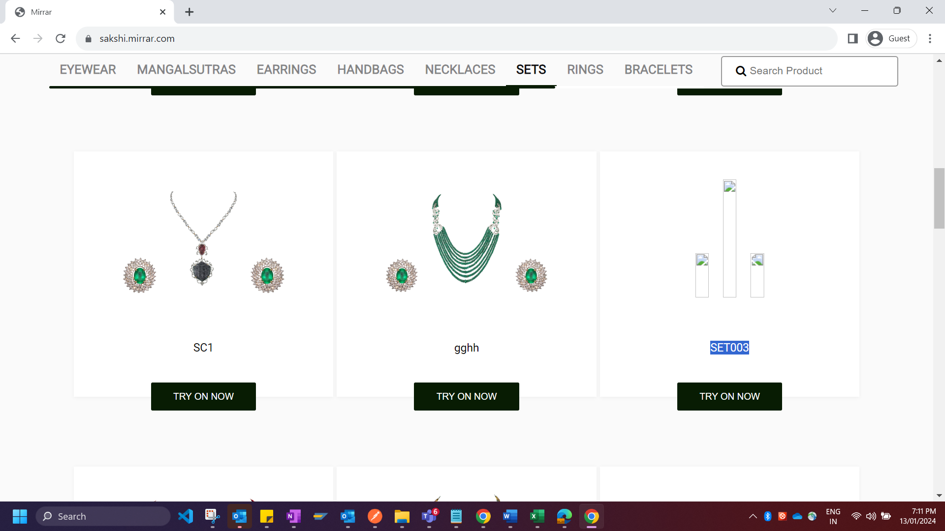

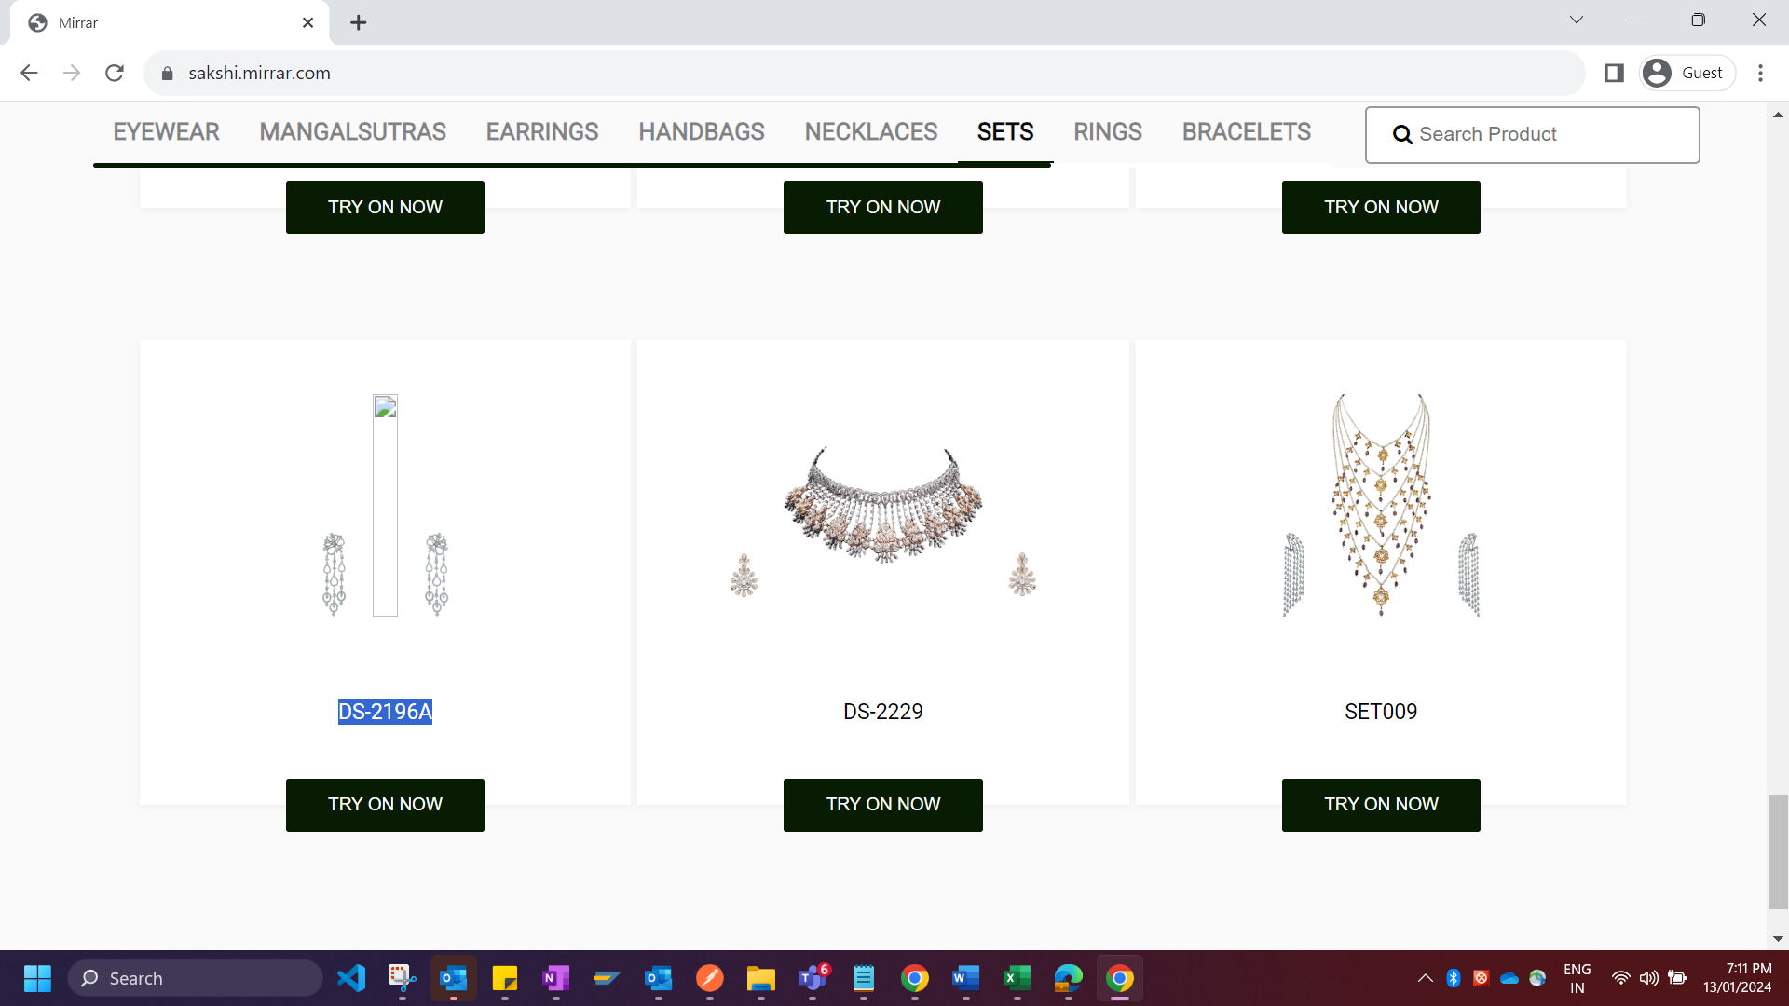

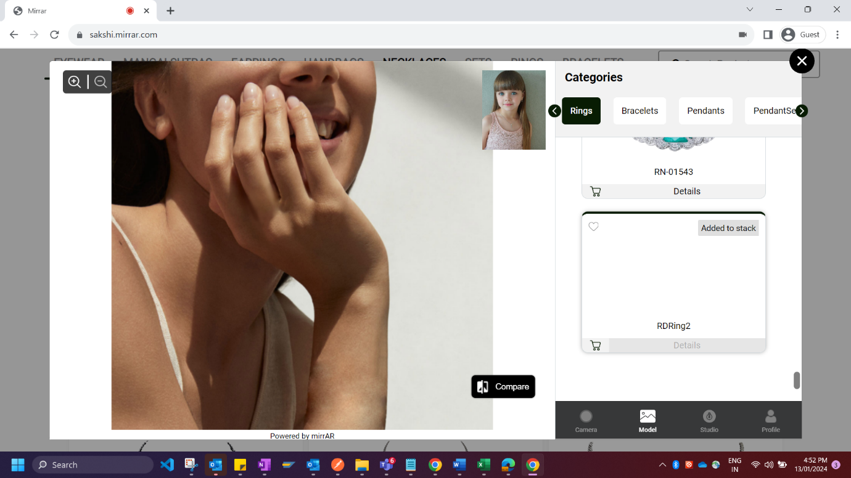

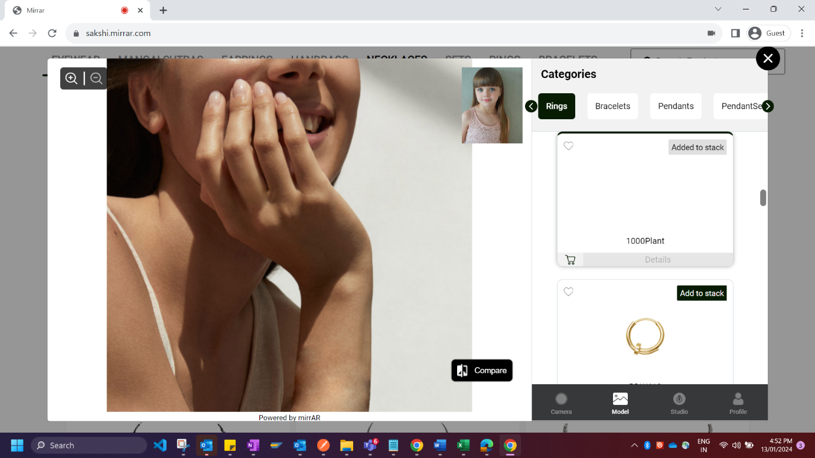

**BUG 5:**

Try on now functionality is not correctly developed for few product items

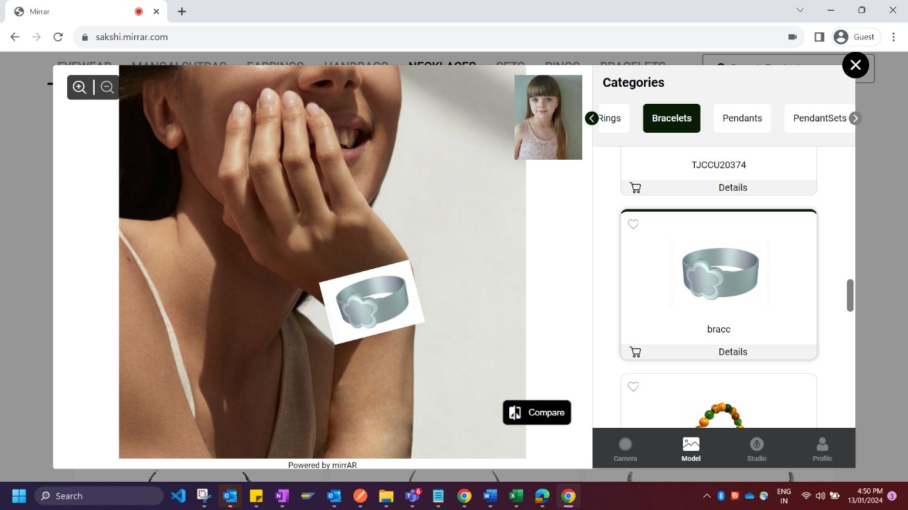

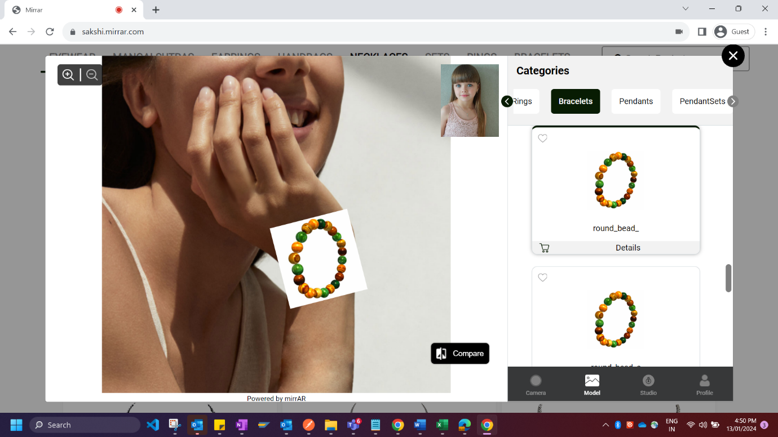

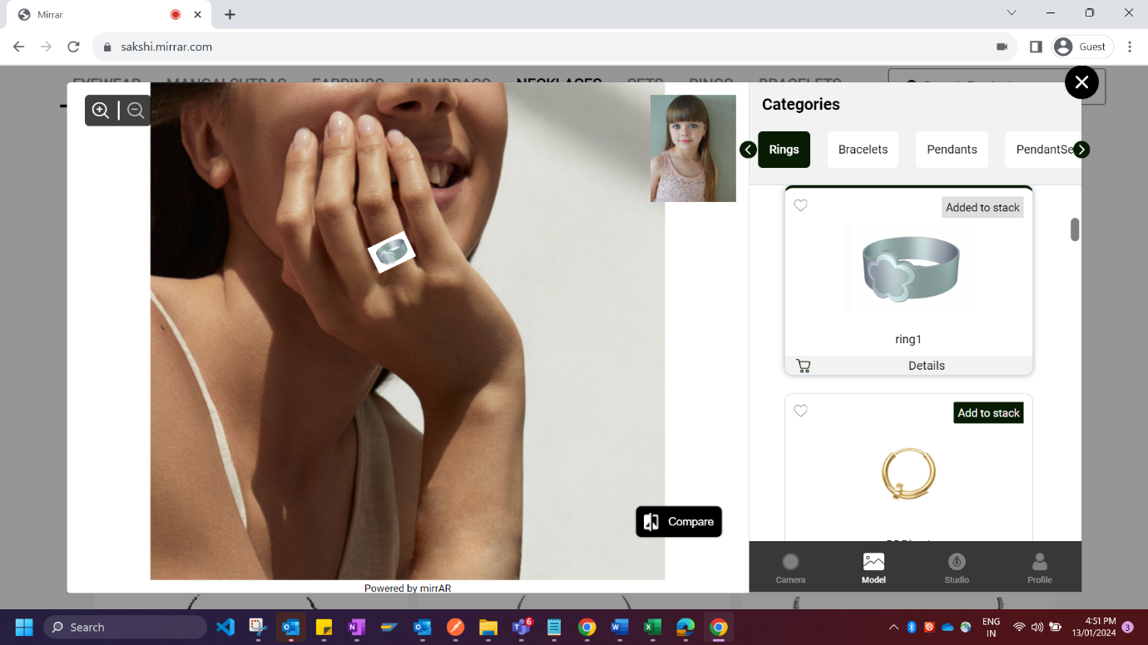

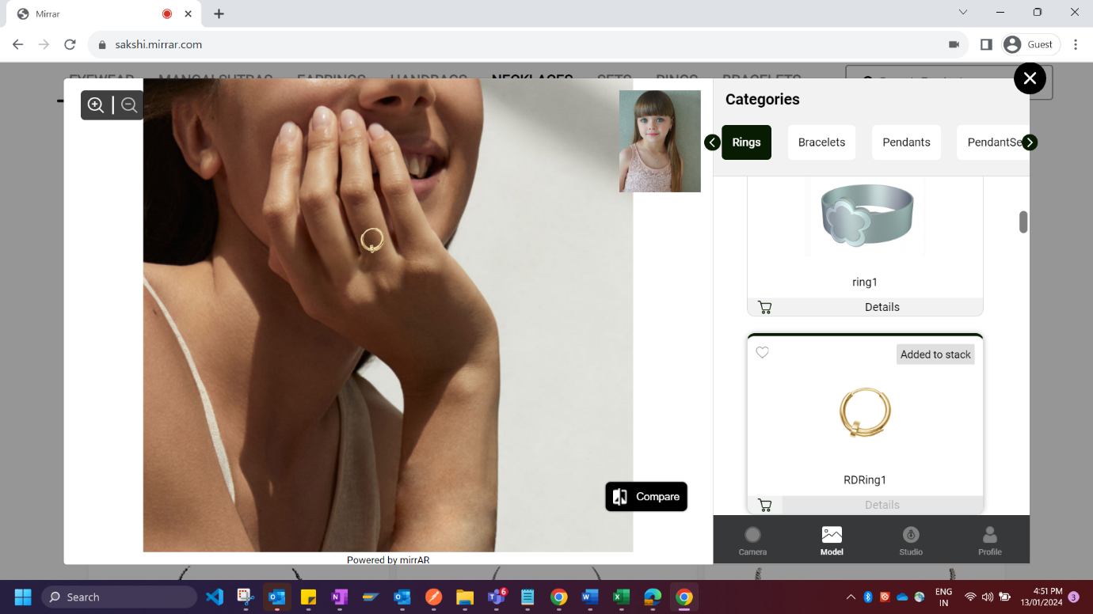

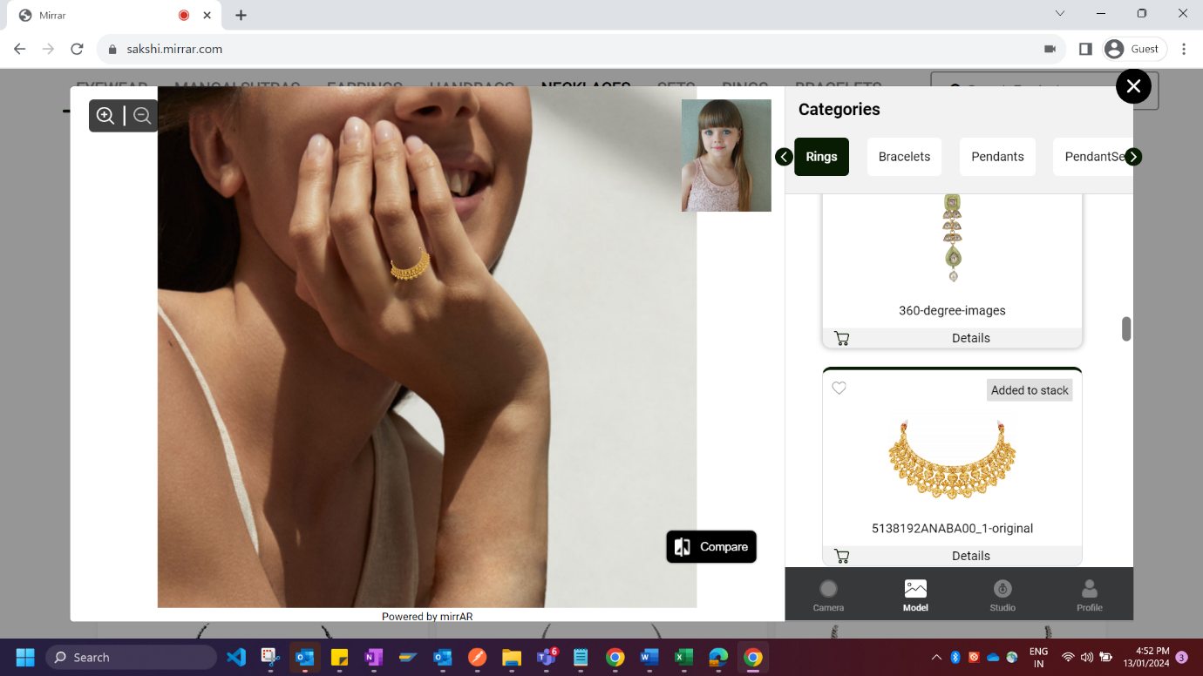

**Bug 6:**  
  
While trying to check “Try on Now” functionality for the product item - **gold-mangalsutra-500x500,** it’s looking as below where the user can’t benefit from this.

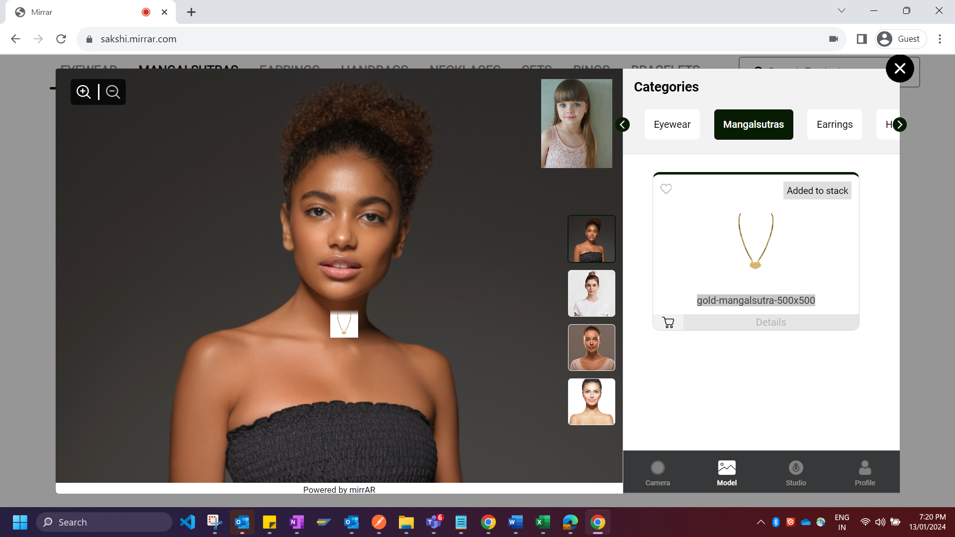

**Bug 7:**

Very Often, we cannot be able to navigate to any other product items once any specific product item has been clicked in Try on now functionality. We are getting the below error like this.  
